## TinyML will soon be everywhere:

TinyML will soon be everywhere, powering the next generation of smart embedded devices. These devices will be in our homes and in very remote locations, enabling remote monitoring for both industry and ecology. Today, in these remote monitoring settings, 99% of raw sensor data is discarded, which is a wealth of data for machine learning!

TinyML can provide a unique solution: by summarizing and analyzing data at the edge on low power embedded devices, TinyML can provide **smart** summary statistics that take these previously lost patterns, anomalies, and advanced analytics into account [[1](https://www.mckinsey.com/~/media/McKinsey/Industries/Technology%20Media%20and%20Telecommunications/High%20Tech/Our%20Insights/The%20Internet%20of%20Things%20The%20value%20of%20digitizing%20the%20physical%20world/The-Internet-of-things-Mapping-the-value-beyond-the-hype.pdf)] [[2](https://hbr.org/webinar/2017/04/whats-your-data-strategy)].

In this reading, we survey a few emerging application areas that have great potential for TinyML. This list is a tiny (no pun intended) preview into the wealth of applications on the horizon. Later in this course we will do some basic review of machine learning, which some of you will need less than others but it is still a good review. In the next two courses we will be diving in much deeper around TinyML.

## Industrial Predictive Maintenance:

In the industrial setting, TinyML is already being used to provide smarter sensing that enables advanced monitoring improving productivity and safety. For example, maintenance and monitoring of remote wind turbines can be quite challenging and time-consuming. However, if we could proactively predict that the machine will have trouble, we can predictively do maintenance ahead of any failures. Such “predictive maintenance” can lead to significant cost savings due to reduced downtimes, better availability of the systems for higher reliability in the product, which leads to overall higher quality of service for end-users/customers.

There are many TinyML applications for predictive maintenance. For instance, an Australian startup, Ping Services, has introduced a novel IoT device that continuously and autonomously inspects a turbine as it’s running. By magnetically attaching to the outside of any turbine (notice the small device in the image below) and analyzing detailed data at the edge and summary data in the cloud, the device can efficiently and effectively alert of any potential issues before a problem arises inside the turbine [[3](https://www.pingmonitor.co/)].

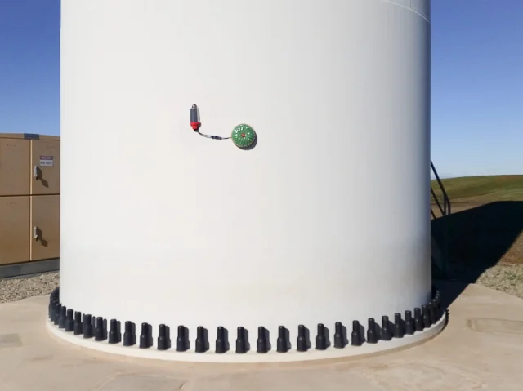 [The Ping Monitor magnetically mounted on a turbine tower. <https://www.engineering.com/ElectronicsDesign/ElectronicsDesignArticles/ArticleID/20662/IoT-Device-Detects-Wind-Turbine-Faults-in-the-Field.aspx>]

<Alt text: Ping monitor magnetically mounted on a turbine tower. The monitor is much smaller than the turbine.>

## Agriculture:

Every day, the cassava crop provides food for more than 500 million African people. However, this vital stable is continuously under attack from a variety of diseases. The team at PlantVillage, led by Dr. Amanda Ramcharan, has developed the Nuru app to help farmers identify and treat these diseases. By running machine learning using TensorFlow Lite on mobile phones, the app enables real-time mitigation without the need for access to the internet -- a crucial requirement for many remote farmers (see the image below for the system in action). The next generation of this system will go farther -- leveraging tinyML and technologies like TensorFlow for Microcontrollers to deploy sensors across remote farms to enable better tracking and analysis [[4](https://grow.google/intl/europe/story/transforming-farmers%E2%80%99-lives-with-just-a-mobile-phone)].

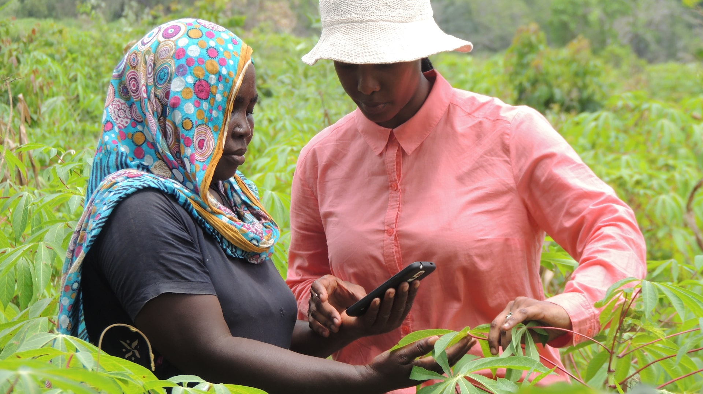

[Using the PlantVillage App in the fields <https://plantvillage.psu.edu/assets/nuru/1920x1080-46e591e30e6d04d3131dcced749b9c3392ff18573fc6a521d9ec23e8be135b88.jpg>]

<Alt text: Two women using the PlantVillage app while in a field with plants.>

## Healthcare:

The Solar Scare Mosquito project deploys small smart Internet of Things (IoT) robotic platforms to help curb the spread of mosquito-borne epidemics such as Malaria, Dengue, and the Zika Virus. The system works by disrupting the mosquito breeding cycle by agitating water likely to contain mosquito larvae. The system uses rain and acoustic sensors to determine when it needs to agitate water to conserve battery and enable it to run on solar power indefinitely. It also sends smart summary statistics and alerts to warn of possible mosquito mass breeding events over lower power low-speed communication protocols. By making the system self-sufficient, small, and affordable, these devices can be deployed widely, preventing mosquitoes spread. All of the necessary components are included in a single component smaller than the size of a soccer ball [[5](https://hackaday.io/project/174575-solar-scare-mosquito-20)].

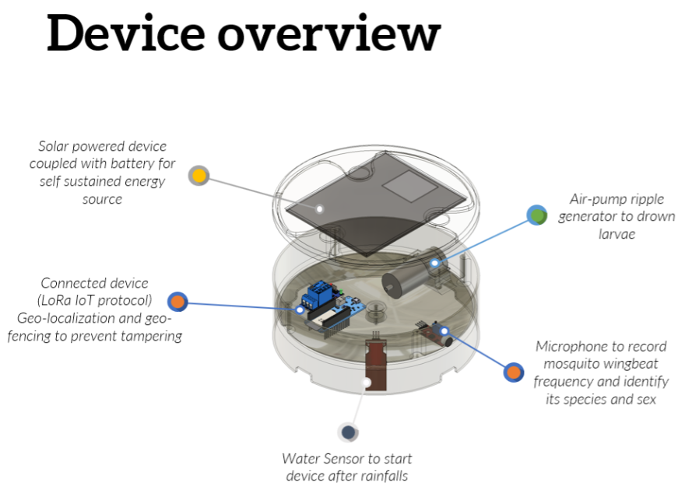

[The Solar Scare Mosquito 2.0 Device <https://hackaday.io/project/174575/gallery#9c9372eb31bc7e8bb99d633a7955d467>]

<Diagram of the Solar Scare Mosquito 2.0 device. Shows the parts including the solar power, air pump, microphone for recording wingbeat frequency, water sensor, external connectivity.>

## Wildlife Conservation:

### On the Land:

TinyML is also already being used for ecological and environmental monitoring. For example, over the past 10 years, the Siliguri-Jalapaiguri railway line in India has had over 200 fatal collisions with elephants. Researchers from the Laboratory of Applied Bioacoustics at the Polytechnic University of Catalonia designed a smart acoustic and thermal sensor system using custom machine learning models running on solar power as an early warning system (see image below—all-in-one package with self-sustained energy source allows proximity to railway without added infrastructure, e.g., power lines) [[6](https://www.zdnet.com/article/elephants-vs-trains-this-is-how-ai-helps-ensure-they-dont-collide/)].

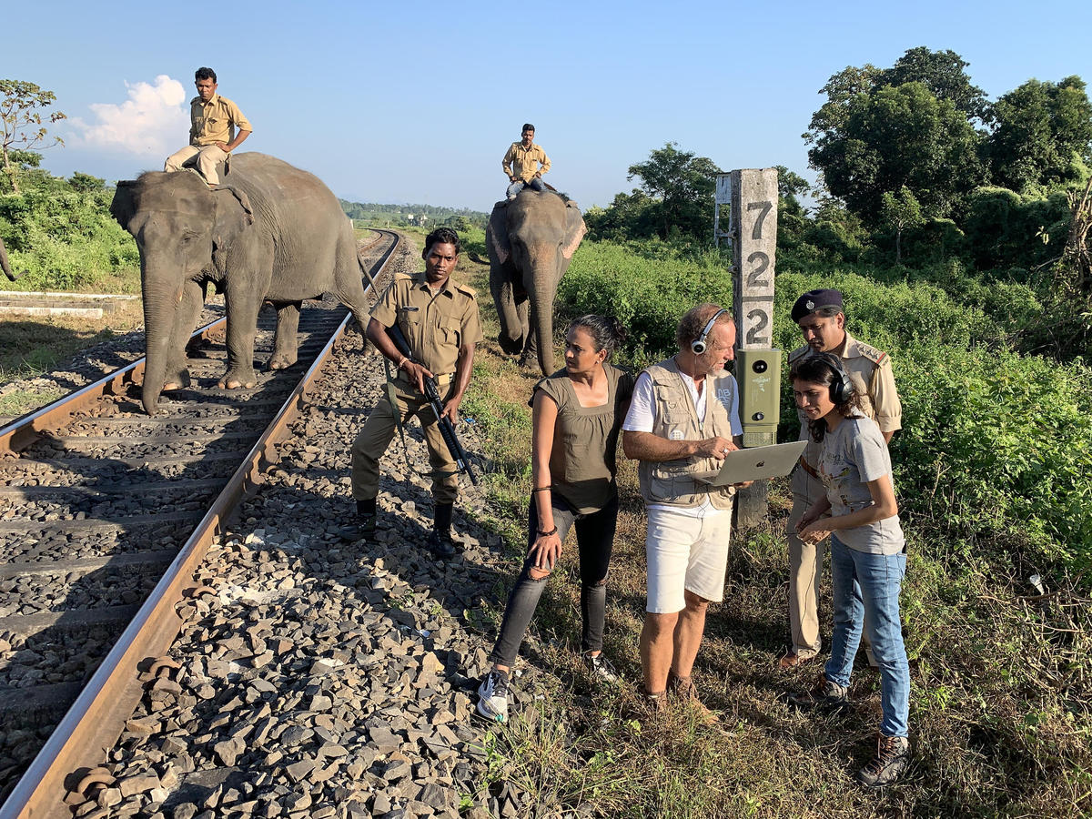

[Testing an acoustic sensor near a train track

<https://www.zdnet.com/article/elephants-vs-trains-this-is-how-ai-helps-ensure-they-dont-collide/>]

<Alt text: team of researchers near train track testing an acoustic sensor so trains and elephants don’t collide.>

### And In The Sea:

Similar systems are also being deployed in the waterways around Seattle and Vancouver to prevent whale strikes in busy shipping lanes. These smart ML powered sensors enable constant real time monitoring and increased density of sensor deployments improving overall system efficiency and efficacy [[7](https://graphics.wsj.com/glider/google-builds-ai-to-help-ships-and-whales-coexist-f4b74f53-bba5-442f-90a4-e42dfb13dad2?mod=e2twd)].

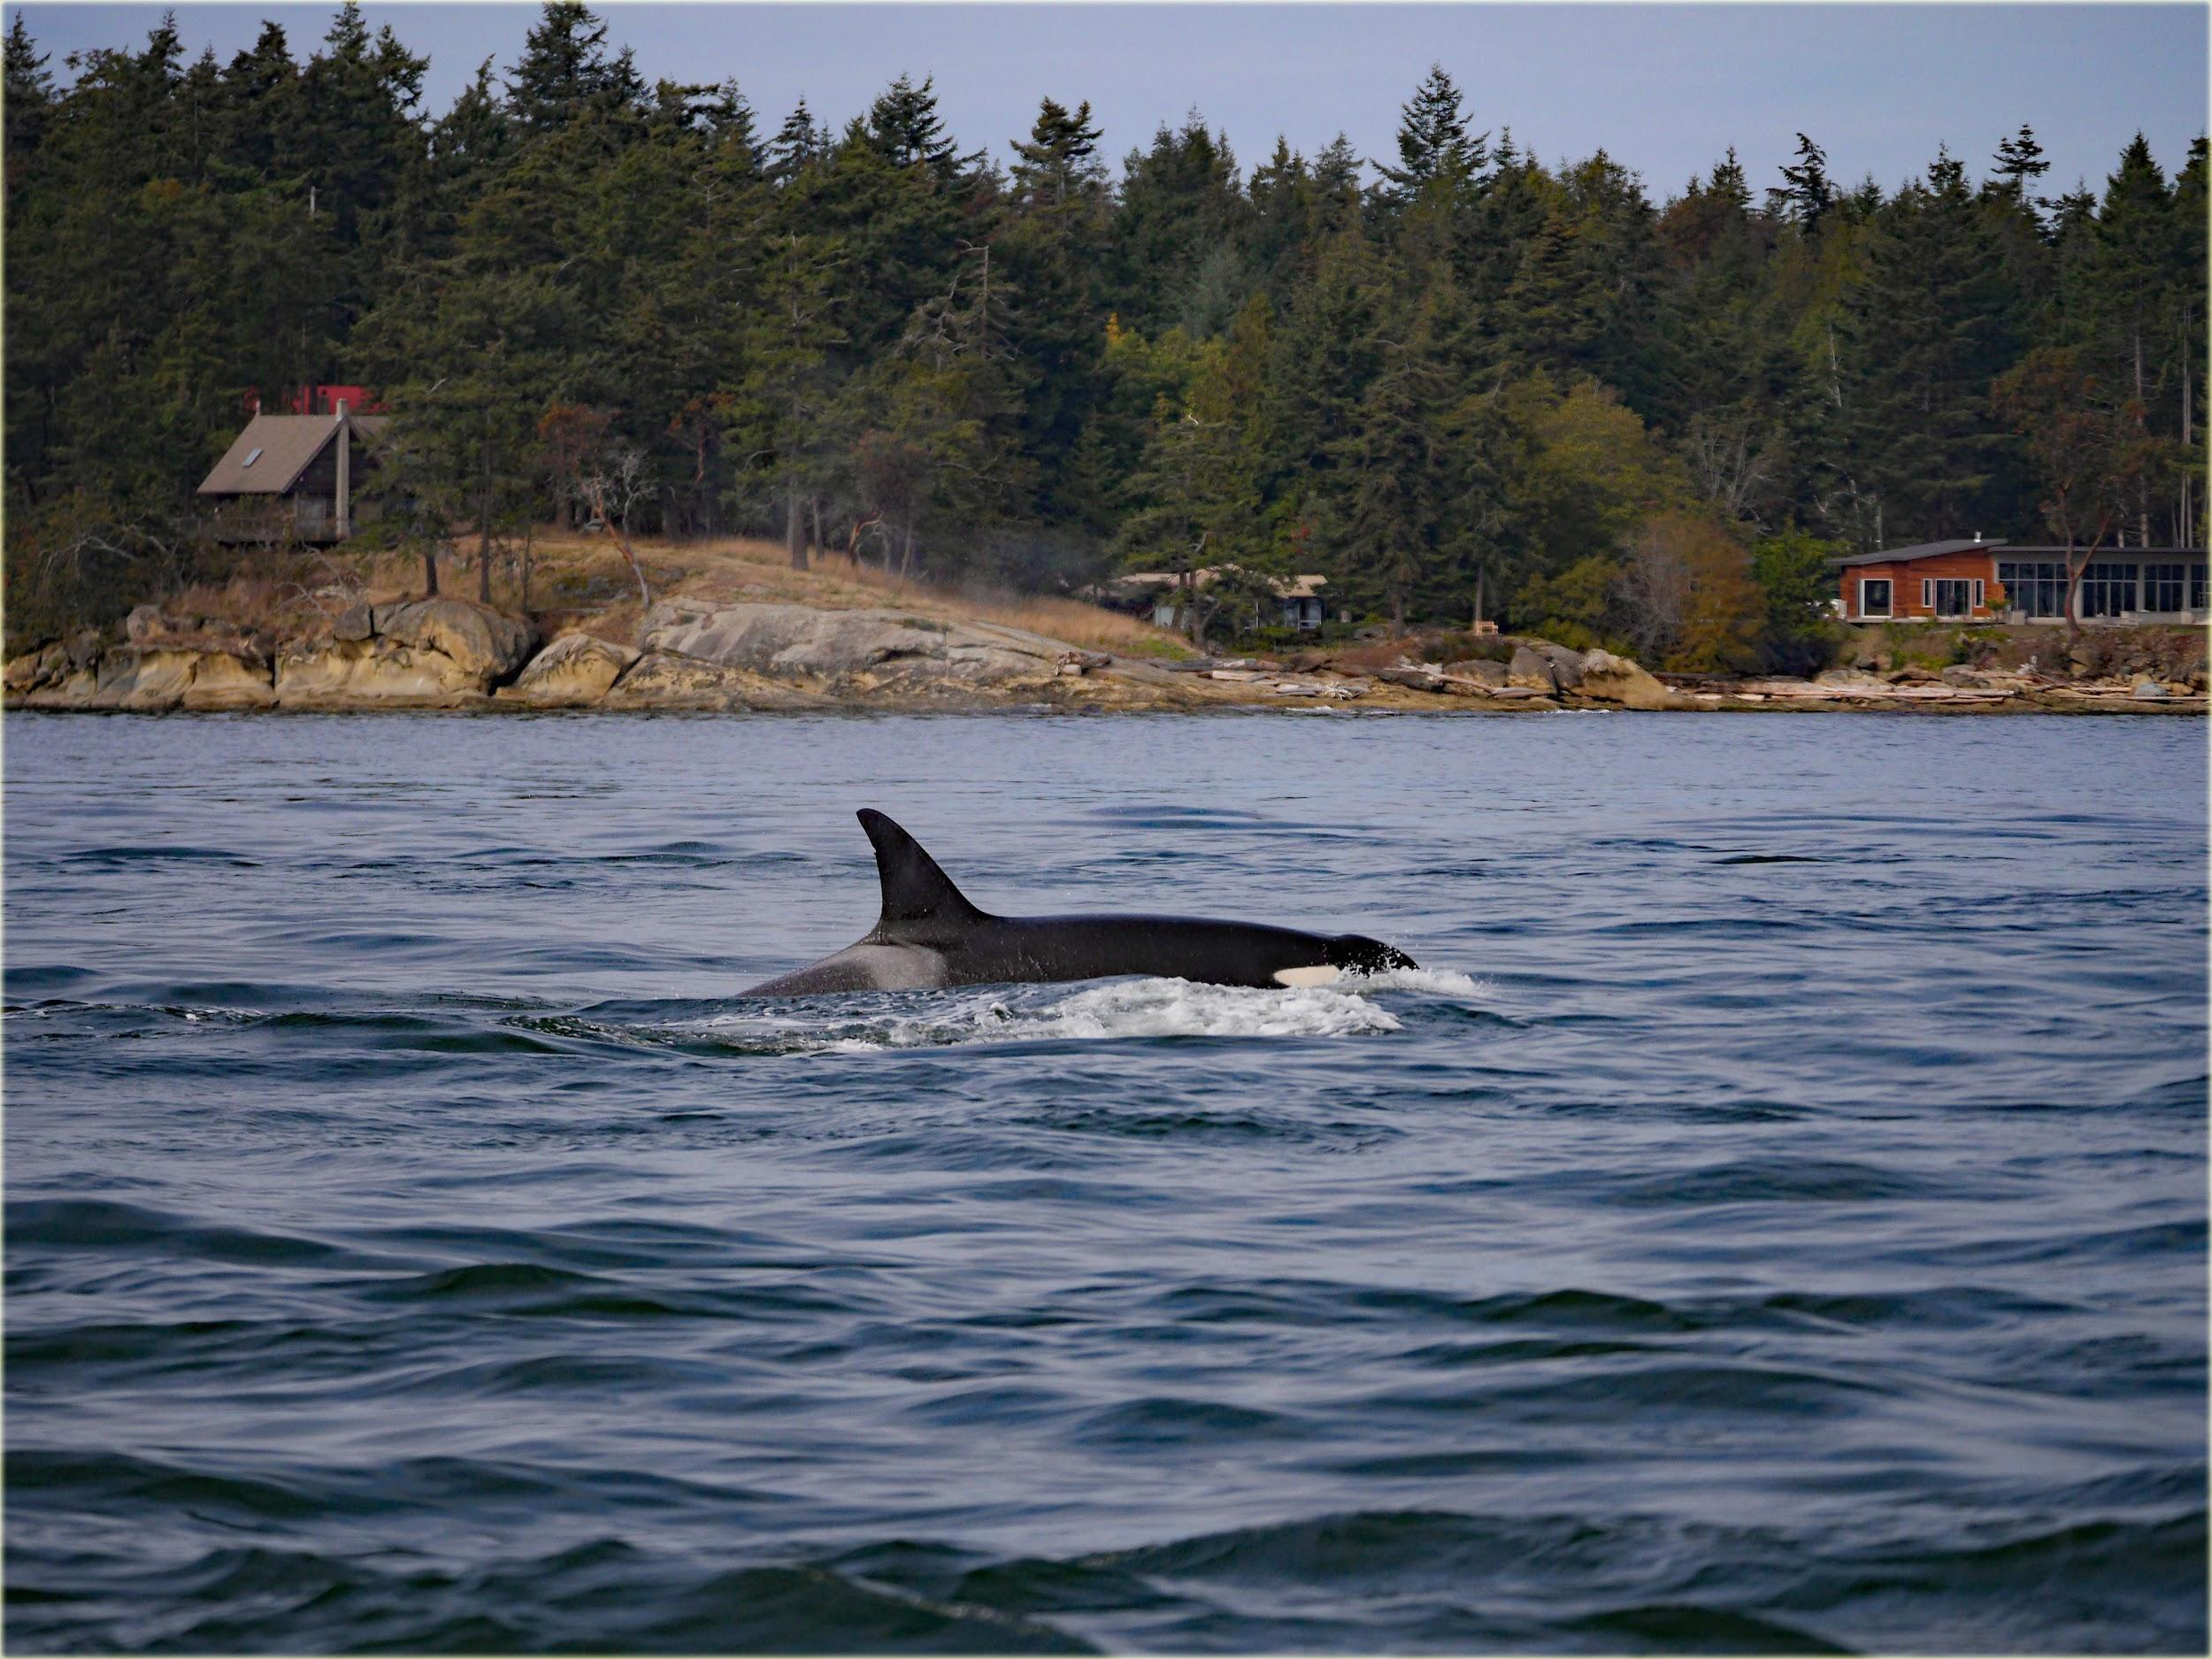

[Orca Whales in the Pacific Northwest Waterways <https://search.creativecommons.org/photos/1f5e1d4b-660b-4b3e-9dd9-a603f09e0035>]

<Alt text: Orca whale swimming in water>

There are a whole host of other existing deployments of TinyML today and we hope that by the end of this course you’ll have the tools and skills to start developing your own applications!